Department of Environmental Quality
Water Resources Division
Aquatic Nuisance Control Program

Fremont Lake Site Visit Report
Date of Site Visit: 09/06/2017, 09/07/2017 Survey by: Ryan Crouch, Eric Bacon, Glen Schmitt
Location: Fremont Lake, Newaygo County Conditions: 9/6 - overcast, light wind. 9/7 – scattered showers, light wind. Sechi Depth of 8.5 feet on 9/7
Overview: A site visit to Fremont Lake in Newaygo County was conducted due to the site having a recent history of poor native plant density and diversity. This history has resulted in recommendations limiting the treatment of native submerged macrophytes. The survey was conducted by ANC/WRD personnel to document the current conditions on the lake, in order to have records of the vegetative community to better understand future permit requests. The shoreline was broken down into 49 survey sections and vegetation was observed following standard DEQ aquatic vegetation survey protocol.
Summary: Overall, vegetation levels are improving but care still needs to be taken when reviewing permit applications for the waterbody. The sandy substrate in large portions of the lake provides poor habitat for species to exist in areas that receive higher amounts of wave action, limiting the potential for growth in the littoral zone. Wild celery was the only species present at common densities (between 20 and 60 percent coverage). Several species were found at sparse levels around the lake (between 2 and 20 percent coverage). These species were naiad, chara, sago pondweed, thin leaf pondweed and Eurasian watermilfoil. Species found at low levels (less than 2 percent coverage) in the lake were cattail, coontail, variable pondweed, swamp loosestrife, yellow waterlily, elodea, pickerel weed, iris, purple loosestrife, bulrush, white waterlily, and curly leaf pondweed. Chemical control activities conducted on the lake in 2017 focused on Eurasian watermilfoil control. The invasive species was still present in the lake but was mixed in with native species instead of forming dense monocultures, so control seem to be effective at limiting the nuisance potential of the species. Curly leaf pondweed was found at one location on the lake, near the southern public access boat ramp. The species may be a recent introduction to the lake, so control in the coming year is advisable to remove the species before it can become an issue.
ANC staff spoke to one resident while performing the survey, the resident was opposed to chemical treatment but could not provide specific examples of how the treatments were negatively impacting the lake. The resident seemed mostly concerned with fish kills that had happened on the lake in the past but in describing when fish kills occurred it is unlikely chemical treatment had any impact.

Table 1. Summary of Survey
Plant Code | Plant Name | Total number of AVAS's for each Density Category |  |  |  |  |  |  | Category Calculations |  |  |  |  | Sum of Previous Four Columns |  | Total Number of AVAS's |  | Quotient of Sum / # of AVAS sites
Plant Code | Plant Name | A | B | C | D |  |  | A x 1 |  | B x10 | C x 40 | D x 80
1 | Eurasian watermilfoil | 16 | 11 | 0 | 0 |  |  | 16 |  | 110 | 0 | 0 | 126 |  | 49 |  | 2.57
2 | Curly leaf pondweed | 1 | 0 | 0 | 0 |  |  | 1 |  | 0 | 0 | 0 | 1 |  | 49 |  | 0.02
3 | Chara | 13 | 10 | 6 | 3 |  |  | 13 |  | 100 | 240 | 240 | 593 |  | 49 |  | 12.10
4 | Thin leaf pondweed | 18 | 11 | 2 | 0 |  |  | 18 |  | 110 | 80 | 0 | 208 |  | 49 |  | 4.24
5 | Flat stem pondweed | 0 | 0 | 0 | 0 |  |  | 0 |  | 0 | 0 | 0 | 0 |  | 49 |  | 0.00
6 | Robbins pondweed | 0 | 0 | 0 | 0 |  |  | 0 |  | 0 | 0 | 0 | 0 |  | 49 |  | 0.00
7 | Variable pondweed | 5 | 1 | 0 | 0 |  |  | 5 |  | 10 | 0 | 0 | 15 |  | 49 |  | 0.31
8 | White stem pondweed | 0 | 0 | 0 | 0 |  |  | 0 |  | 0 | 0 | 0 | 0 |  | 49 |  | 0.00
9 | Richardsons pondweed | 0 | 0 | 0 | 0 |  |  | 0 |  | 0 | 0 | 0 | 0 |  | 49 |  | 0.00
10 | Illinois pondweed | 0 | 0 | 0 | 0 |  |  | 0 |  | 0 | 0 | 0 | 0 |  | 49 |  | 0.00
11 | Large leaf pondweed | 0 | 0 | 0 | 0 |  |  | 0 |  | 0 | 0 | 0 | 0 |  | 49 |  | 0.00
12 | American pondweed | 0 | 0 | 0 | 0 |  |  | 0 |  | 0 | 0 | 0 | 0 |  | 49 |  | 0.00
13 | Floating leaf pondweed | 0 | 0 | 0 | 0 |  |  | 0 |  | 0 | 0 | 0 | 0 |  | 49 |  | 0.00
14 | Water stargrass | 0 | 0 | 0 | 0 |  |  | 0 |  | 0 | 0 | 0 | 0 |  | 49 |  | 0.00
15 | Wild Celery | 5 | 24 | 14 | 5 |  |  | 5 |  | 240 | 560 | 400 | 1205 |  | 49 |  | 24.59
16 | Sagitteria | 0 | 0 | 0 | 0 |  |  | 0 |  | 0 | 0 | 0 | 0 |  | 49 |  | 0.00
17 | Native milfoil | 0 | 0 | 0 | 0 |  |  | 0 |  | 0 | 0 | 0 | 0 |  | 49 |  | 0.00
18 | Whorled watermilfoil | 0 | 0 | 0 | 0 |  |  | 0 |  | 0 | 0 | 0 | 0 |  | 49 |  | 0.00
19 | Various leaf watermilfoil | 0 | 0 | 0 | 0 |  |  | 0 |  | 0 | 0 | 0 | 0 |  | 49 |  | 0.00
20 | Coontail | 16 | 1 | 0 | 0 |  |  | 16 |  | 10 | 0 | 0 | 26 |  | 49 |  | 0.53
21 | Elodea | 8 | 0 | 0 | 0 |  |  | 8 |  | 0 | 0 | 0 | 8 |  | 49 |  | 0.16
22 | Bladderwort | 0 | 0 | 0 | 0 |  |  | 0 |  | 0 | 0 | 0 | 0 |  | 49 |  | 0.00
23 | Bladderwort (mini) | 0 | 0 | 0 | 0 |  |  | 0 |  | 0 | 0 | 0 | 0 |  | 49 |  | 0.00
24 | Buttercup | 0 | 0 | 0 | 0 |  |  | 0 |  | 0 | 0 | 0 | 0 |  | 49 |  | 0.00
25 | Najas spp. | 15 | 12 | 4 | 6 |  |  | 15 |  | 120 | 160 | 480 | 775 |  | 49 |  | 15.82
26 | Brittle naiad | 0 | 0 | 0 | 0 |  |  | 0 |  | 0 | 0 | 0 | 0 |  | 49 |  | 0.00
27 | Sago pondweed | 12 | 20 | 5 | 1 |  |  | 12 |  | 200 | 200 | 80 | 492 |  | 49 |  | 10.04
30 | White waterlily | 1 | 0 | 0 | 0 |  |  | 1 |  | 0 | 0 | 0 | 1 |  | 49 |  | 0.02
31 | Yellow waterlily | 2 | 1 | 0 | 0 |  |  | 2 |  | 10 | 0 | 0 | 12 |  | 49 |  | 0.24
32 | Watershield | 0 | 0 | 0 | 0 |  |  | 0 |  | 0 | 0 | 0 | 0 |  | 49 |  | 0.00
33 | Small duckweed | 0 | 0 | 0 | 0 |  |  | 0 |  | 0 | 0 | 0 | 0 |  | 49 |  | 0.00
34 | Great duckweed | 0 | 0 | 0 | 0 |  |  | 0 |  | 0 | 0 | 0 | 0 |  | 49 |  | 0.00
35 | Watermeal | 0 | 0 | 0 | 0 |  |  | 0 |  | 0 | 0 | 0 | 0 |  | 49 |  | 0.00
36 | Arrowhead | 0 | 0 | 0 | 0 |  |  | 0 |  | 0 | 0 | 0 | 0 |  | 49 |  | 0.00
37 | Pickerelweed | 3 | 0 | 0 | 0 |  |  | 3 |  | 0 | 0 | 0 | 3 |  | 49 |  | 0.06
38 | Arrow arum | 0 | 0 | 0 | 0 |  |  | 0 |  | 0 | 0 | 0 | 0 |  | 49 |  | 0.00
39 | Cattail | 21 | 7 | 0 | 0 |  |  | 21 |  | 70 | 0 | 0 | 91 |  | 49 |  | 1.86
40 | Bulrush | 1 | 0 | 0 | 0 |  |  | 1 |  | 0 | 0 | 0 | 1 |  | 49 |  | 0.02
41 | Iris | 3 | 0 | 0 | 0 |  |  | 3 |  | 0 | 0 | 0 | 3 |  | 49 |  | 0.06
42 | Swamp Loosestrife | 14 | 0 | 0 | 0 |  |  | 14 |  | 0 | 0 | 0 | 14 |  | 49 |  | 0.29
43 | Purple Loosestrife | 1 | 0 | 0 | 0 |  |  | 1 |  | 0 | 0 | 0 | 1 |  | 49 |  | 0.02

Table 2. Section Breakdown of Vegetation Coverage
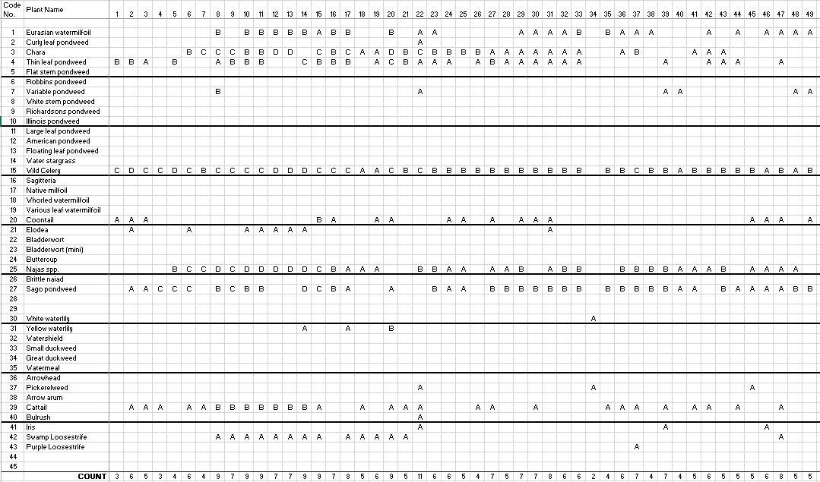

Figure 1. Map of AVAS Survey
