Author’s name: Erick Elgin
Headline: Salting Our Lakes
Secondary Headline: Salting roads, parking lots, and sidewalks can turn our “fresh” water salty.
Spreading salt on roads, parking lots, and sidewalks is a common winter past time for many Michiganders. When snow falls and ice forms, road salt (e.g., sodium chloride) is used to reduce the melting point of water, which promotes ice melt when temperatures drop below freezing. This practice has proven to be an effective method at keeping our paths safe since the 1940’s. In fact, depending on the severity of the winter, Michigan has applied between 343,200 to 759,248 tons of road salt per year to our state highways alone.
Unfortunately, the application of salt to roads and other surfaces comes at an environmental cost. Freshwater lakes, rivers, and groundwater resources are becoming saltier. When snow and ice melt, the road salt does not go away. Instead, it runs off or leaches into freshwater systems, with many potential consequences. Chloride, which makes up about 60 percent of road salt, is a detrimental pollutant in excess quantities. Elevated amounts of chloride are toxic to fish, aquatic plants, aquatic insects, amphibians, zooplankton, and algae. If road salt concentrations reach sustained elevated levels many freshwater organisms will be unable to survive in that waterbody.
Road salt can also be detrimental to lakes in other ways. Water polluted by road salt is denser than freshwater and therefore salt contaminated water will settle to the deepest part of the lake where it can accumulate. This chemical stratification, or the development of layers of water due to density differences, can prevent the natural mixing of lakes, which in turn, can lead to a near permanent layer in the lake’s bottom waters. Often that bottom layer becomes devoid of oxygen and is unable to support aquatic insects and fish life.
A recent study published in the Proceedings of the National Academy of Sciences identified that the amount of impervious surfaces, defined as areas that do not allow water to infiltrate, such as roads, parking lots, and residential walkways are a major predictor of road salt pollution in lakes when within 500 meters of a lake. In these situations, best practices should be implemented to minimize salt application.
Simple actions for homeowners include:
- Use less. More salt does not equate with more melting.
- Remove snow and ice manually. The more you remove, the less salt will need to be applied.
- Sweep up any excess salt visible on a dry sidewalk.
- Do not apply salt below 15°F – most salt products will not work below that temperature.
- Know your deicer
For more information on best practices for homeowners check out this resource from the Minnesota Pollution Control Agency.
Simple actions that snow removal professionals can take include:
- Calibrate your equipment
- Use stream nozzles for anti-ice brine, not fan nozzles
- Do not apply anti-ice brine to pavement with snow or ice
- Use pavement temperature not air temperature to determine which de-icer product to use
- Do not apply road salt when pavement temperatures are below 15°F
For more information on best practices for snow professionals visit Be Salt Wise or download MSU Extension’s Michigan’s Winter Maintenance Manual.
This article was published by Michigan State University Extension. For more information, visit http://www.msue.msu.edu. To have a digest of information delivered straight to your inbox, visit www.msue.msu.edu/newsletters. To contact an expert in your area, visit http://expert.msue.msu.edu, or call 888-MSUEMI (888-678-3464).

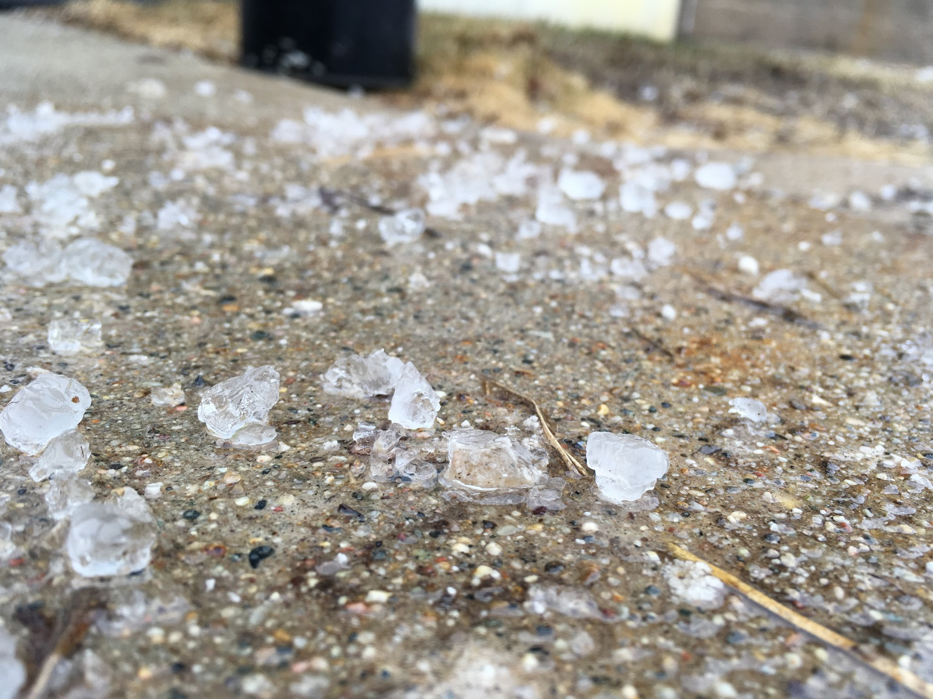
Photo credit: Erick Elgin

